***SOLARBOT***

**Intelligent Virtual Assistant for Solar Energy Solutions**

**Himanshu Singh**

**18-may-2024**

**Abstract**

The adoption of solar energy is pivotal in addressing global energy needs sustainably. However, navigating the complexities of solar installations, product selections, and maintenance can be challenging for consumers and businesses alike. SOLARBOT aims to bridge this gap by providing a comprehensive virtual assistant dedicated to solar energy solutions.

**SOLARBOT** is an intelligent ChatBot designed to assist users with a wide array of solar energy-related queries. Leveraging advanced Natural Language Processing (NLP) technologies and pre-trained models, SOLARBOT offers accurate, real-time responses, ensuring users receive relevant and reliable information. Key functionalities include guiding users through the process of solar installations, offering detailed product recommendations based on individual needs and site assessments, and providing ongoing support for maintenance and troubleshooting.

The ChatBot operates through a user-friendly web interface, ensuring accessibility and ease of use. It can handle various inquiries such as cost estimations, potential energy savings, suitability of different solar products, and the steps involved in installation. By integrating SOLARBOT into their service offerings, solar energy providers can enhance customer satisfaction, streamline the consultation process, and ultimately drive greater adoption of solar technology.

**Problem Statement :**

In current times, the global shift towards renewable energy is crucial for sustainability and reducing carbon emissions, with solar energy playing a key role in this transition. However, the adoption process for solar energy remains complex and intimidating for many consumers and businesses. This complexity arises from several factors, including a *lack of understanding about the benefits*, costs, technologies, installation processes, and maintenance requirements of solar energy systems. The wide range of available solar products further complicates decision-making, often leading to confusion and decision paralysis. Traditional customer service methods, which are resource-intensive and lack scalability, struggle to provide the necessary personalized guidance and timely responses that consumers need. This results in inconsistent customer experiences and inefficiencies in addressing customer queries. Additionally, there exists a significant educational gap; potential adopters frequently lack access to accurate and comprehensive information about solar energy, making it difficult for them to make informed decisions. These challenges also hinder customer engagement, as traditional marketing and customer service approaches often fail to maintain sustained interest and effectively educate potential customers. Solar providers spend considerable time and resources on customer support, handling repetitive queries and providing detailed consultations that could otherwise be automated or streamlined.

SOLARBOT is designed to address these issues by providing an intelligent virtual assistant that delivers accurate, real-time, and personalized support for solar energy-related queries. By leveraging advanced Natural Language Processing (NLP) technology, SOLARBOT aims to simplify the decision-making process for consumers by providing clear and concise information about solar energy benefits, costs, technologies, and installation processes. It offers tailored product recommendations based on individual energy requirements and site conditions, ensuring users receive relevant and personalized advice.

**Market / Customer/ Business Need Assessment** :

As a product idea, SOLARBOT offers an innovative solution to simplify and streamline the adoption of solar energy for consumers and businesses. Leveraging advanced Natural Language Processing (NLP) technology, SOLARBOT serves as an intelligent virtual assistant tailored specifically for the solar energy market.

SOLARBOT offers personalized recommendations by analyzing user inputs and site conditions, providing tailored solutions, cost-benefit analyses, and return on investment projections. It serves as a comprehensive educational resource hub, delivering up-to-date information on solar energy benefits, technologies, installations, and maintenance in an easily understandable format. Additionally, SOLARBOT provides round-the-clock support for troubleshooting and maintenance, ensuring users stay informed about system performance and any potential issues or upgrades. By automating sales and consultation processes, SOLARBOT enhances efficiency, accelerates decision-making, and boosts customer satisfaction. Furthermore, SOLARBOT collects and analyzes user interactions, offering valuable insights to refine marketing strategies, improve service offerings, and identify opportunities for product development.

**Target Specifications and Characterization :**

**Below are the list of our Targets:**

**Residential Consumers:**

*Needs:* Individuals seeking to reduce energy costs, achieve energy independence, and contribute to sustainability.

*Characteristics:* Interested in understanding the benefits of solar energy, cost-effectiveness, and ease of installation. May have limited technical knowledge but desire personalized advice and support.

***Commercial and Industrial Clients*:** Businesses, including small to large enterprises, across various industries.

*Needs***:** Companies aiming to lower operational costs, meet sustainability goals, and enhance brand image.

*Characteristics:* Require scalable solar solutions tailored to their specific energy needs and site conditions. Seek comprehensive analyses of cost savings, ROI projections, and regulatory compliance.

***Solar vendors:*** Solar installation companies, consultants, and energy advisors.

*Needs:* Tools to streamline sales processes, improve customer interactions, and optimize service offerings.

*Characteristics:* Require automation of initial consultations, accurate product recommendations, and data-driven insights for marketing and product development. Value scalability, efficiency, and customer satisfaction.

**Geographic Coverage:**

**Global Reach:** Targeting regions with high solar energy potential and increasing adoption rates.

**Localized Support:** Offering multilingual support and region-specific resources to address diverse customer needs and regulatory requirements.

.

**Business Model :­­­**

The business model for SOLARBOT centers around providing comprehensive value-added services tailored to the needs of residential consumers, commercial clients, and solar energy providers within the solar energy market. Through a subscription-based model, SOLARBOT offers personalized recommendations, educational resources, ongoing support, and automation features to its users. Different subscription plans cater to varying levels of service and features, ensuring flexibility and scalability. Additionally, SOLARBOT provides customized enterprise solutions for solar energy providers, including white-label versions, CRM integration, and analytics dashboards. Consulting services and training programs are also offered to businesses and individuals seeking in-depth knowledge about solar energy adoption and maintenance. Furthermore, SOLARBOT acts as a lead generation tool, capturing user data and preferences to generate leads and referrals for partner companies. The aggregation and anonymization of user data enable SOLARBOT to provide valuable insights and analytics to industry stakeholders, thereby creating additional revenue streams. By leveraging strategic partnerships and collaborations, SOLARBOT aims to enhance its offerings and expand its market reach, ultimately driving adoption of solar energy solutions and contributing to the sustainability of the energy sector.

**Concept Generation :**

Concept generation for SOLARBOT involves brainstorming and ideation sessions to explore innovative features, functionalities, and applications of the virtual assistant within the solar energy domain. Here are some concept ideas to consider:

**Virtual Solar Energy Advisor:** Develop SOLARBOT as a virtual advisor that guides users through the entire process of adopting solar energy, from initial inquiry to installation and maintenance. The bot can provide personalized recommendations based on user inputs, site conditions, energy needs, and budget constraints.

**Interactive Solar Energy Calculator:** Integrate an interactive solar energy calculator into SOLARBOT, allowing users to input their location, energy usage, roof size, and other relevant factors to estimate potential savings, payback periods, and return on investment for solar installations.

**Integration with Smart Home Devices:** Enable integration with smart home devices and Internet of Things (IoT) platforms, allowing SOLARBOT to control and monitor solar energy systems remotely. Users could receive real-time updates on energy production, consumption, and savings through their smart home devices or mobile apps.

**Gamification and Incentive Programs:** Introduce gamification elements and incentive programs into SOLARBOT to encourage user engagement and promote solar energy adoption. Users could earn points, rewards, or discounts for completing certain actions, such as sharing their solar journey on social media or referring friends to the platform.

**Community Forum and Peer Support:** Create a community forum within SOLARBOT where users can connect with other solar energy enthusiasts, share experiences, ask questions, and provide support to one another. Peer-to-peer interactions could foster a sense of community and empowerment among users.

**Continuous Learning and Improvement:** Implement machine learning algorithms and data analytics capabilities into SOLARBOT to continuously learn from user interactions, improve recommendations, and anticipate user needs over time. This iterative approach could enhance the accuracy and relevance of the virtual assistant's responses.

**Final Product Prototype with Schematic Diagram :**

The final prototype is a user-friendly online solar energy advisory platform incorporating advanced AI Chabot capabilities. It consists of intuitive interfaces for both solar energy providers and customers, facilitating data management, consultation processing, and real-time assistance. The centralized database ensures efficient management of solar data, while the AI ChatBot enhances customer interaction by providing personalized recommendations, answering queries, and guiding users through the solar adoption process. This seamless integration of technology aims to revolutionize the solar energy experience, optimizing efficiency, and enhancing customer satisfaction.

**Schematic diagram**

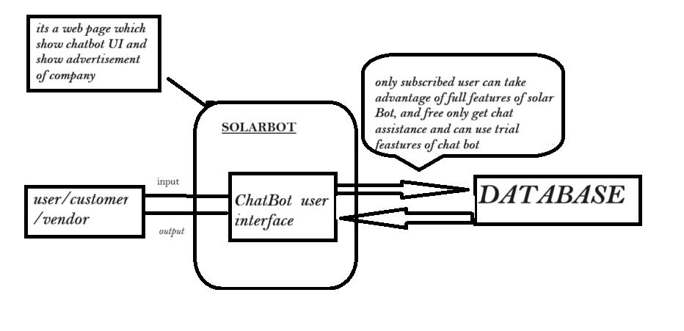

**Conclusion:**

In conclusion, the implementation of the proposed SOLARBOT holds significant promise for solar energy providers and consumers alike. By addressing the complexities inherent in solar energy adoption and management, the platform not only enhances user satisfaction but also streamlines processes, ultimately leading to improved efficiency and sustainability. The convenience, accuracy, and real-time assistance offered by SOLARBOT align with the evolving needs of individuals and businesses navigating the solar energy landscape. Moreover, by leveraging advanced technology to optimize the solar energy experience, users can differentiate themselves and foster trust among their clientele. As a result, investing in SOLARBOT can prove instrumental in driving growth and sustainability for solar energy stakeholders in today's competitive market.